**REPORT**

**ON**

**ZOOM SEMINAR**

“Exploring Hardware of PC & IOT DEVICE”

From Safal Lamichhane

To: Dr. Wei Dai

# Introduction:

## Speakers Information

This report is entitled to Zoom Seminar given on Exploring Hardware of PC & IoT Device by Mr. Jayanga V. Godamuna. He is a graduate student from the Cybersecurity department from Sri Lanka. The speaker is interested in this topic to gain in-depth knowledge of various types of hardware components. He wants to gain detailed knowledge on IoT devices like Raspberry Pi 3: A powerful computer with a small size like a credit card. Furthermore, he also wants to monitor the CPU temperature when the hardware is in operation along with the usage of memory, disk drivers.

## Topic

From a layman's point of view, Hardware is those things that you can touch and feel. They are the physical components that help the computer to run and function properly. The computer is like a human body and the brain can be said as the CPU. It is one of the components of our computer. There are generally 5 components of hardware in a PC. They are input, processing, storage, output, and communication devices. IoT (Internet of Things) is the process of connecting any devices with the internet. For instance, the door can be opened instantly with the use of smartphones. It is done by an IoT door lock. Don't you get curious about how does this works?

The work done by the speaker is to explain internal and external hardware. He also explains some types of computers like stored-program & fixed program computers. Later works on IoT Device (Raspberry PI 3): Monitor CPU temperature, performance, IOT connection via SSH.

## Objectives:

* Introduction and Identification of Core components of PC
* Introducing IOT devices
* Identifying core components of IoT devices
* Monitoring performance of IoT devices

# Content

## Core Components of PC

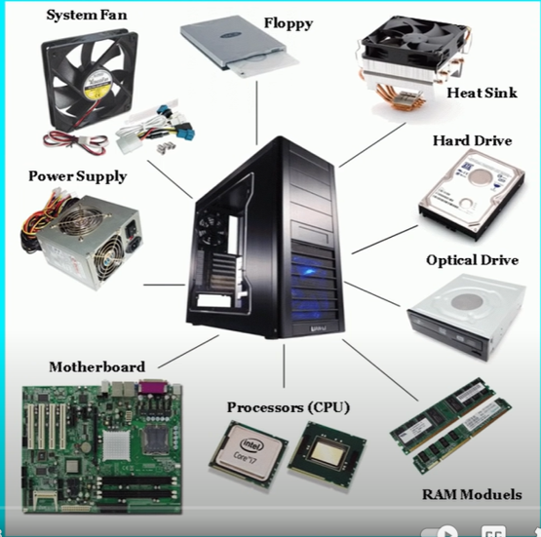

Fig: Core components of PC

As shown in the figure above, these are the core hardware components of the computer. The motherboard is the most important of the computer. The CPU is the engine, harddisks are the secondary storage, CMOS for BIOS, RAM for fast performance, System Fan for cooling the PC, and lastly power supply for giving power required. PC are stored programs and calculators can be called fixed programs. Processors can be distinguished by the number of cores used. Intel and Ryzen are the main processor types. Ryzen has more cores in comparison with Intel so can be said better? Talking about a hard drive, SSD is better than SATA.

## IoT Devices (Raspberry PI3)

IoT devices provide transparency, control, and performance. The seminar talks about **Raspberry PI 3** and its core components, which is an IoT device. Raspberry PI 3 is an ultra-small, affordable computer costing less than most video games. It can be used to learn to code, building robots, creating unique projects. It was designed to teach young people how to learn to program.

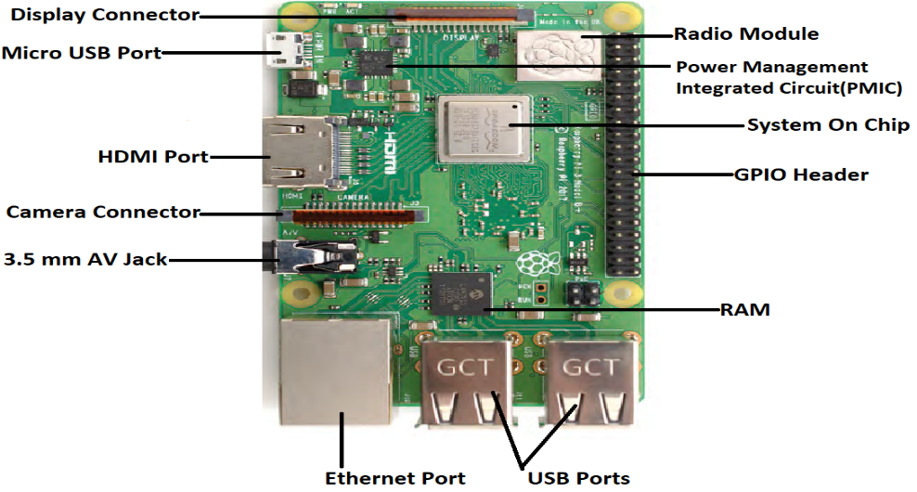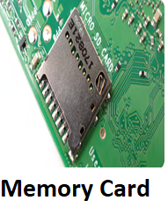

Fig: Raspberry PI 3

As shown in the figure above, we can see each component, port on display. In a standard computer, all the component's ports are hidden behind the box. The speaker demonstrated the connection between the Raspberry Pi and Kali Linux using SSH following the temperature of the CPU in real-time.

# Discussion

The work is original and very much useful. The work is very much useful as Mr. Godamuna just mentioned how to check the temperature. As we don't have any cooling mechanism, I found out that the temperature should be checked constantly, and liquid immersion is used for cooling. It has application in various fields like agriculture. IoT can be helpful in agriculture as we use various sensors and water the crops. We can collect temperature and humidity readings and accordingly water the plant. We can make a security system that can capture the motions with the use of Raspberry Pi. It is a perfect tool to check any unwanted intrusions in our home while we are gone. We can now replace desktop computers with a Raspberry PI so that computers can be accessed easily. You can carry your computer from place to place easily with your saved work.

# Conclusion

I have learned about CPU, Chipset, Processor, CMOS are directly attached to or part of the motherboard. In computer hardware, there are different types of ports like RJ-45, parallel ports, VGA connector that is used to connect external devices to the computer. IoT uses AI, big data, sensors to create a system for specific products. IoT can be used in any field and helps to improve control, transparency, and performance. Even though Raspberry PI 3 is small, it can be used for coding, building robots, and many more. This topic carries great importance as IOT can be used in every field and helps to maximize the output.

I believe that IoT has significant usage in various fields that seem common to most of us but are dealing with it. For instance, we can take remote village areas where there is no mobile network. In those places, the villagers sometimes get sick, and their homes are usually far from each other. If there is an emergency, then they could always communicate with the use of this device. With the help of Raspberry PI, a private radio FM station can be broadcasted in those places which can help them in communication. There might be some difficulty with the range of transmission, and the audio needs to be preloaded, but I think this can be really used in those remote areas and impact positively in their lives.

# References

<https://pubmed.ncbi.nlm.nih.gov/3780060/>

<https://www.youtube.com/watch?v=ctAVC2JwEwI>

### **https://www.raspberrypi.org/magpi-issues/Beginners_Guide_v1.pdf**

### **https://download1.gigabyte.com/Files/Manual/mb_manual_ga-b85m-d3h_e.pdf**